|  |  |  |  |  |
| --- | --- | --- | --- | --- |
| **Test Case** | **Input** | **Expected output** | **Actual Output** | **Pass?** |
| 1A | 2,5,7,9,11 | Minimum =2 Maximum = 11 | Minimum =2 Maximum = 11 | yes |
| 1B | 0,55,79,222,32 | Minimum =0 Maximum = 222 | Minimum =0 Maximum = 222 | yes |
| 1C | 1,6,9, -2,5 | Minimum =-2 Maximum = 9 | Minimum =-2 Maximum = 9 | yes |
| 1D | 2,5,70, -5, j | Please only enter an integer. Restart and try again. | Please only enter an integer. Restart and try again. | yes |
|  |  |  |  |  |
| 2A | What is your selection: 1  Please enter your first number:5 Please enter your second number:7 | You selected addition.  …  The result of 5+ 7 is 12. | You selected addition.  …  The result of 5+ 7 is 12. | yes |
| 2B | What is your selection: 3  Please enter your first number:10 Please enter your second number:0 | You cannot divide by zero | You cannot divide by zero | yes |
| 2C | What is your selection: 0 | Incorrect selection. Please restart and try again. | Incorrect selection. Please restart and try again. | yes |
| 2D | What is your selection: 5  Please enter your first number:46 Please enter your second number:7 | You selected modulus.  …  The result of 46 % 7 is 4. | You selected modulus.  …  The result of 46 % 7 is 4. | yes |

1A) 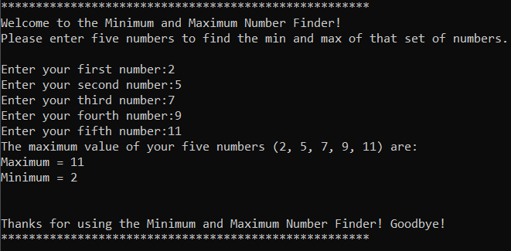

1B) 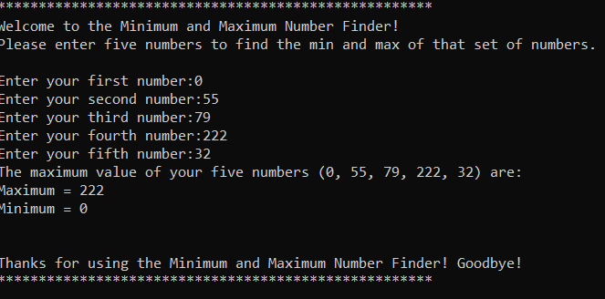

1C) 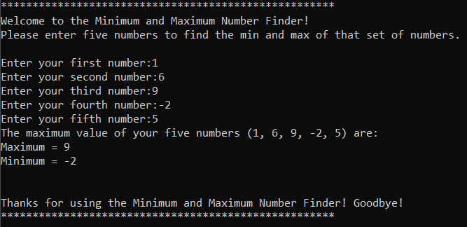

1D) 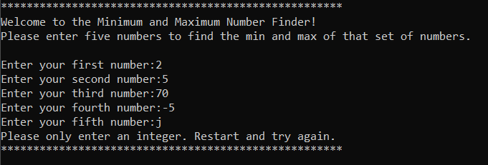

2A)

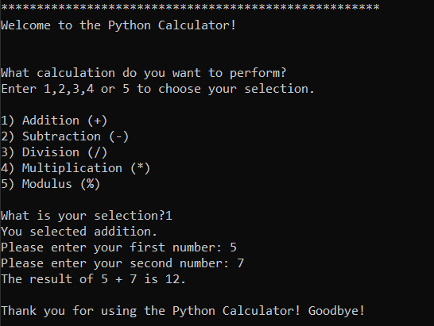

2B)  
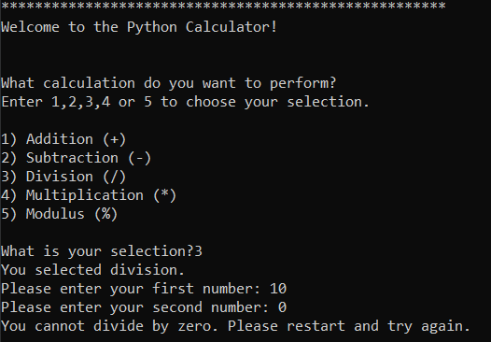

2C)   
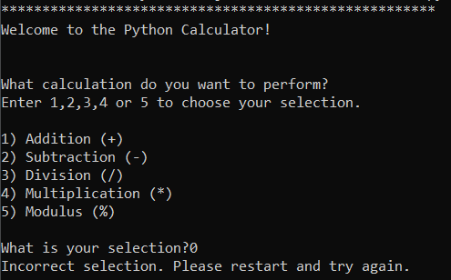

2D)   
